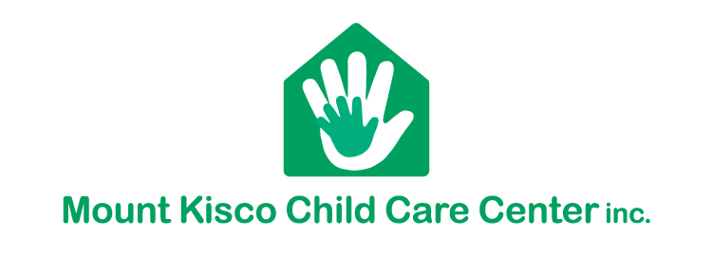

SUMMER / FALL ENROLLMENT 2022

School Age Program and Summer Camp
We are beginning the summer and fall enrollment process.
Please submit a separate form for each child. Be sure to complete both parts of the form.

Return to the reception desk by March 4, 2022
Any forms returned after March 4th will be subject to a $25 administrative fee.
***************************************************************************************
Summer 2022: School Age Summer Camp 7/5 – 8/26
We are currently operating from 7:30am-5:30 pm
If you are not currently enrolled in the AS program, there is an extra fee for the week of 6/27
enrollment for that week is based on availability.
MKCCC will be closed 7/4 for Independence Day
We require that you leave a $250 non-refundable deposit to secure your spot in the camp program when you return this form. The $250 deposit will be applied to your July tuition.
[ ] will attend
My child: ____________________________________________________, [ ] will not be attending.

Days Attending: Monday ( ) Tuesday ( ) Wednesday ( ) Thursday ( ) Friday ( )

Parent Signature _______________________________ Date______________________________

***************************************************************************************
September 2022: The School Age Program re-opens Wednesday, Sept. 7th
If your child is not attending MKCCC Summer Camp, but will return in September, you are required to pay a “commitment fee” of $250. This non-refundable deposit will be applied to your September tuition.
[ ] will attend
My child:____________________________________________________, [ ] will not be attending.

After School: Monday ( ) Tuesday ( ) Wednesday ( ) Thursday ( ) Friday ( )

Early Morning Club: Monday ( ) Tuesday ( ) Wednesday ( ) Thursday ( ) Friday ( )

___________________________________________________ _______________________
Parent Signature Date

